

Lab 5

BS-AI(22) | F22607017

LAB Task

Syed Zeeshan

2023

**Lab Tasks:**

**Task 1:**

**Q. Write a C++ program for insertion sort for floating point numbers?**

**CODE:**

#include<iostream>

using namespace std;

void insertionSort(float arr[], int n) {

float key;

for (int i = 1; i < n; i++) {

key = arr[i];

int j = i - 1;

while (j >= 0 && arr[j] > key) {

arr[j + 1] = arr[j];

j = j - 1;

}

arr[j + 1] = key;

}

}

void printArray(float arr[], int size){

for (int i = 0; i < size; i++)

cout << arr[i] << " ";

cout << endl;

}

int main() {

const int size = 5;

float arr[size];

cout << "Enter " << size << " Floating point numbers :" << endl;

for (int i = 0; i < size; i++)

cin >> arr[i];

insertionSort(arr, size);

cout << "Sorted Array after Selection sort is : ";

printArray(arr, size);

return 0;

}

OUTPUT:

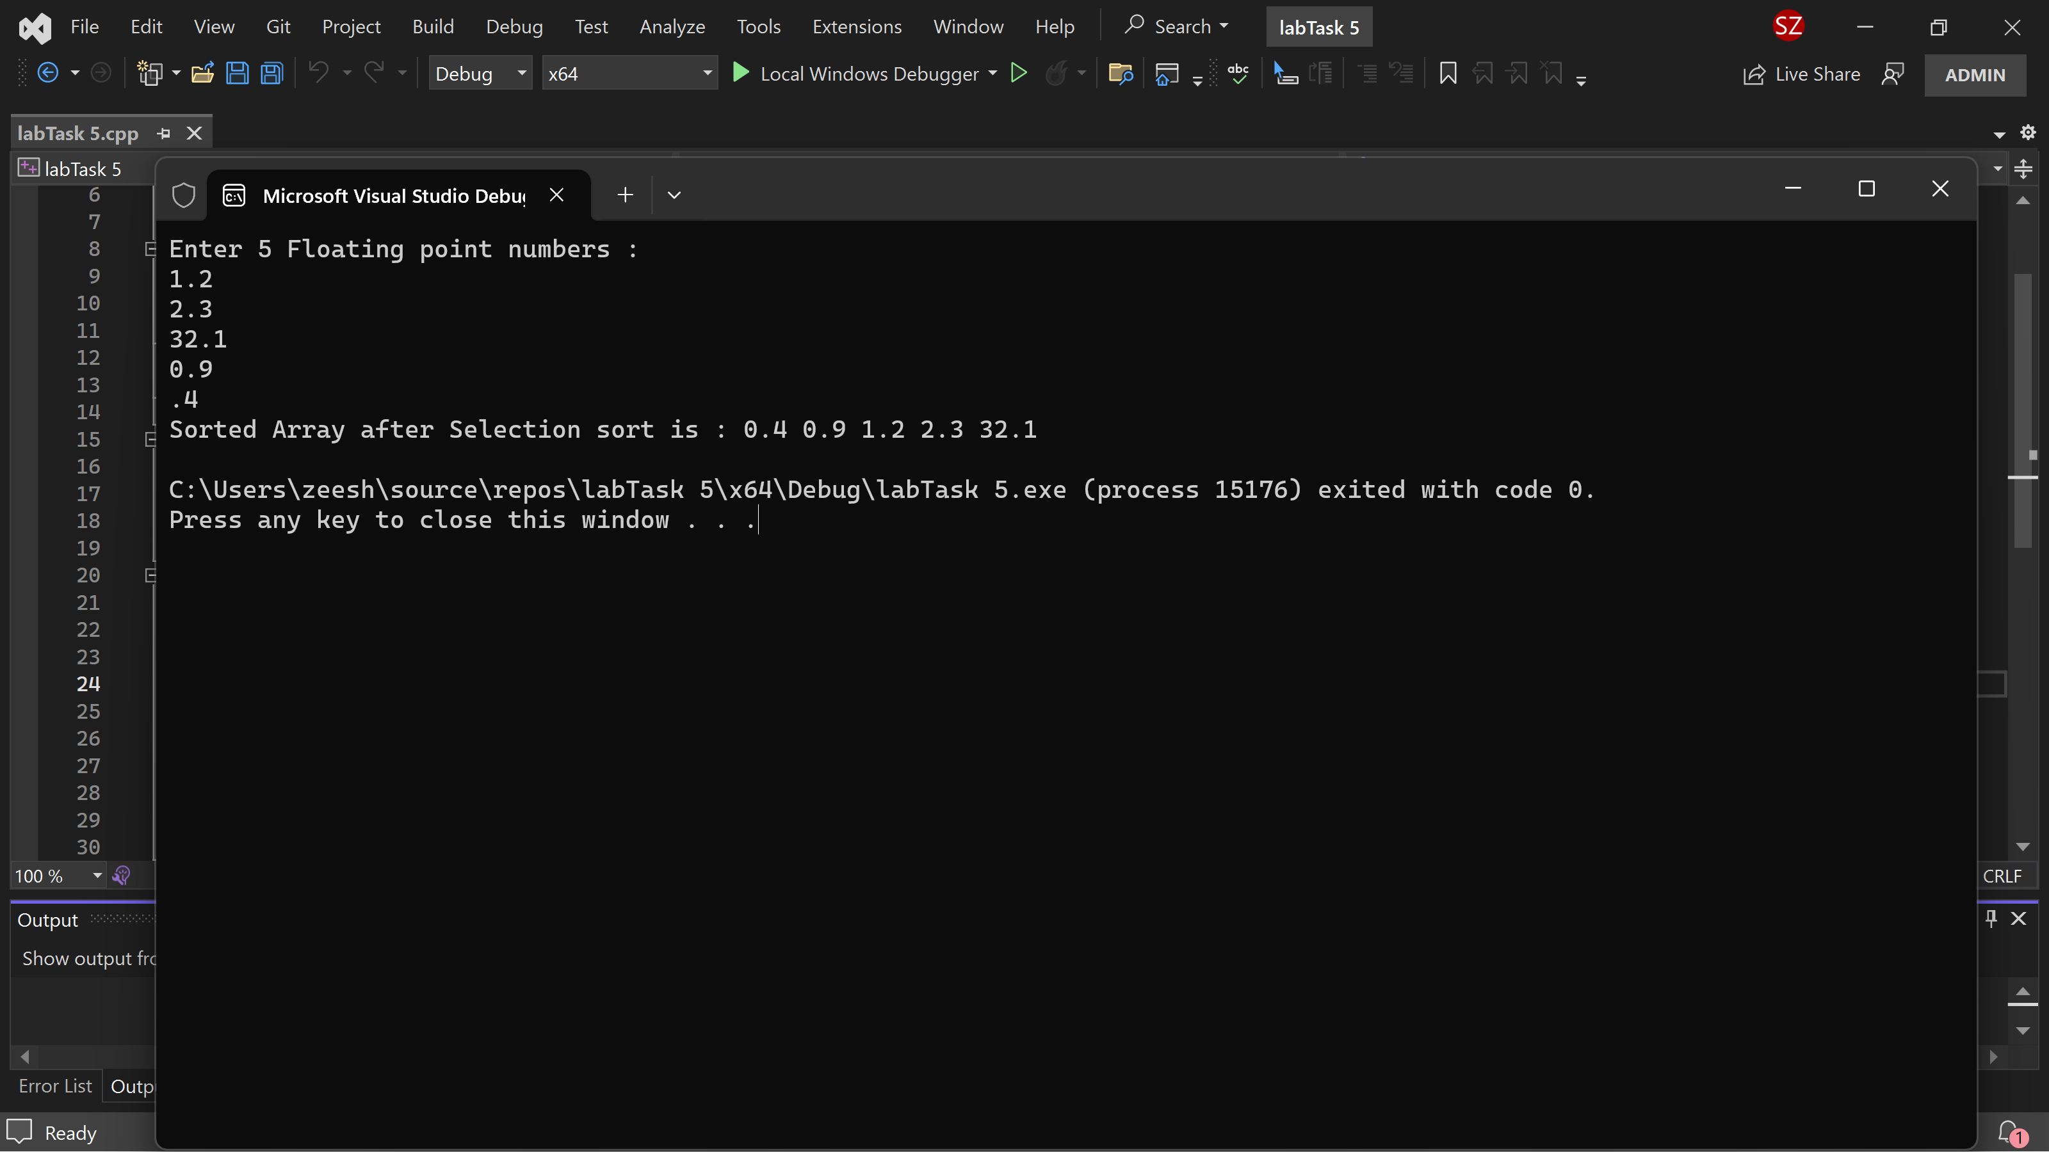

Post Lab Tasks

Write a C++ program of bubble sorting for floating point numbers?

•Measure execution time for sorting an array of 1000 numbers using Chrono library

CODE:

#include <iostream>

#include <chrono>

void bubbleSort(float arr[], int size) {

for (int i = 0; i < size - 1; ++i) {

for (int j = 0; j < size - i - 1; ++j) {

if (arr[j] > arr[j + 1]) {

// Swap arr[j] and arr[j + 1]

float temp = arr[j];

arr[j] = arr[j + 1];

arr[j + 1] = temp;

}

}

}

}

int main() {

const int size = 1000;

float numbers[size];

for (int i = 0; i < size; ++i) {

numbers[i] = static_cast<float>(rand()) / static_cast<float>(RAND_MAX);

}

auto start = std::chrono::high_resolution_clock::now();

bubbleSort(numbers, size);

auto end = std::chrono::high_resolution_clock::now();

auto duration = std::chrono::duration_cast<std::chrono::microseconds>(end - start);

std::cout << "Sorted array:\n";

for (int i = 0; i < size; ++i) {

std::cout << numbers[i] << " ";

}

std::cout << "\n\nExecution time for sorting " << size << " numbers: " << duration.count() << " microseconds\n";

return 0;

}

OUTPUT:

